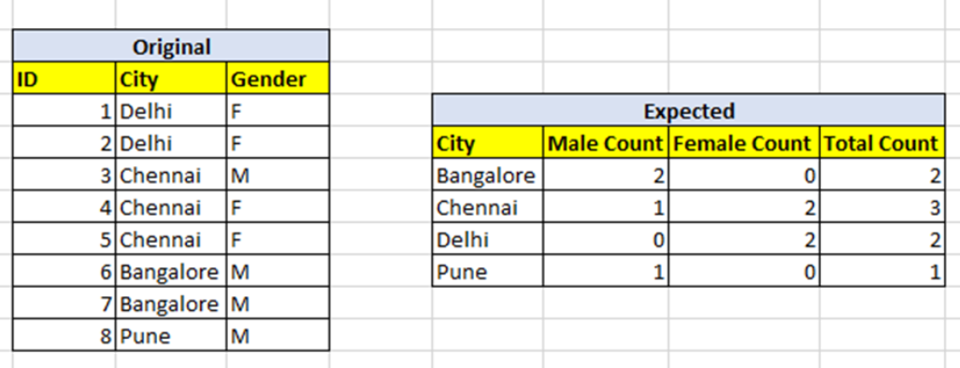
select CITY,COUNT(case when GEND='M' then 1 end) as MAIL_COUNT,
COUNT(case when GEND='F' then 1 end)as FEMALE_COUNT,
COUNT(GEND) from GENDER
GROUP BY CITY;

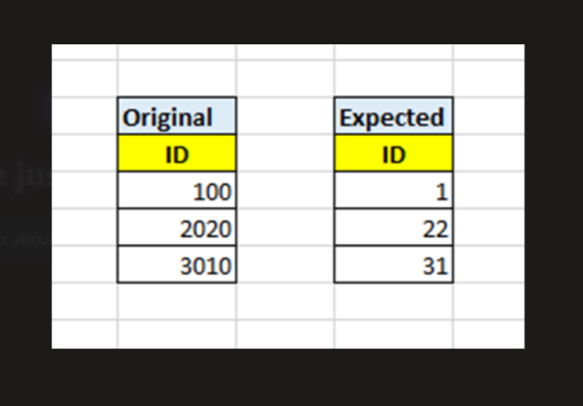

select replace(id,0) from num;

Select
empno,ename,sal,
lag(sal,1,0) over(order by sal)as prv_market,
lead(sal,1,0) over(order by sal)as next_market
from emp;

